**DAILY ONLINE ACTIVITIES SUMMARY**

|  |  |  |  |  |  |  |  |  |
| --- | --- | --- | --- | --- | --- | --- | --- | --- |
| **Date:** | 29/05/2020 | | | | | **Name:** | D Richard Franklin | |
| **Sem & Sec** | Fourth SEM section A | | | | | **USN:** | 4AL18CS020 | |
| **Online Test Summary** | | | | | | | | |
| **Subject** | | Operating System | | | | | | |
| **Max. Marks** | | 30 | | **Score** | | | 28 | |
| **Certification Course Summary** | | | | | | | | |
| **Course** | [Certified Kubernetes Administrator (CKA) with Practice Tests](https://www.udemy.com/course/certified-kubernetes-administrator-with-practice-tests/) | | | | | | | |
| **Certificate Provider** | | | Udemy | | **Duration** | | | 3 Hour |
| **Coding Challenges** | | | | | | | | |
| **Problem Statement:**  1. Write a Java program to Find size of the largest ‘+’ formed by all ones in a binary matrix  2. Write a C Program to generate first N Armstrong Numbers | | | | | | | | |
| **Status:** Completed | | | | | | | | |
| **Uploaded the report in Github** | | | | | YES | | | |
| **If yes Repository name** | | | | | <https://github.com/richard3658/lockdown-coding> | | | |
| **Uploaded the report in slack** | | | | | YES | | | |

**Online Test Details:**

The online test was from module 2 which was about Multi-threaded Programming. There were 30 questions and the duration was 45 minutes. The questions were optimal and were easy. The score that I got in the test is 28/30.

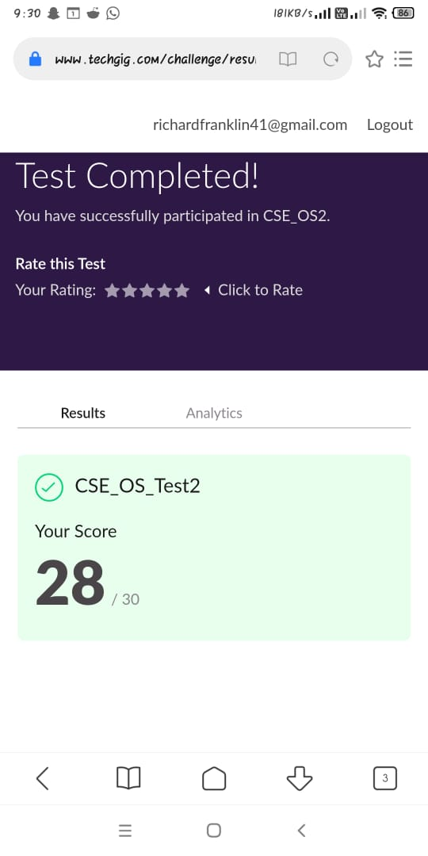

**Certification Course Details:**

**Name of the course**: [Certified Kubernetes Administrator (CKA) with Practice Tests](https://www.udemy.com/course/certified-kubernetes-administrator-with-practice-tests/)

**Certificate Provider**: Udemy

This course has 17 sections and the total duration is 15 hours.

In the eleventh day I went through the section of the course that explained about cluster maintenance and security. Security of the cloud computing and how safe and efficient it is.

**Snapshot:**



**Online Coding Details:**

Problem 1: (using java) Write a Java program to Find size of the largest ‘+’ formed by all ones in a binary matrix

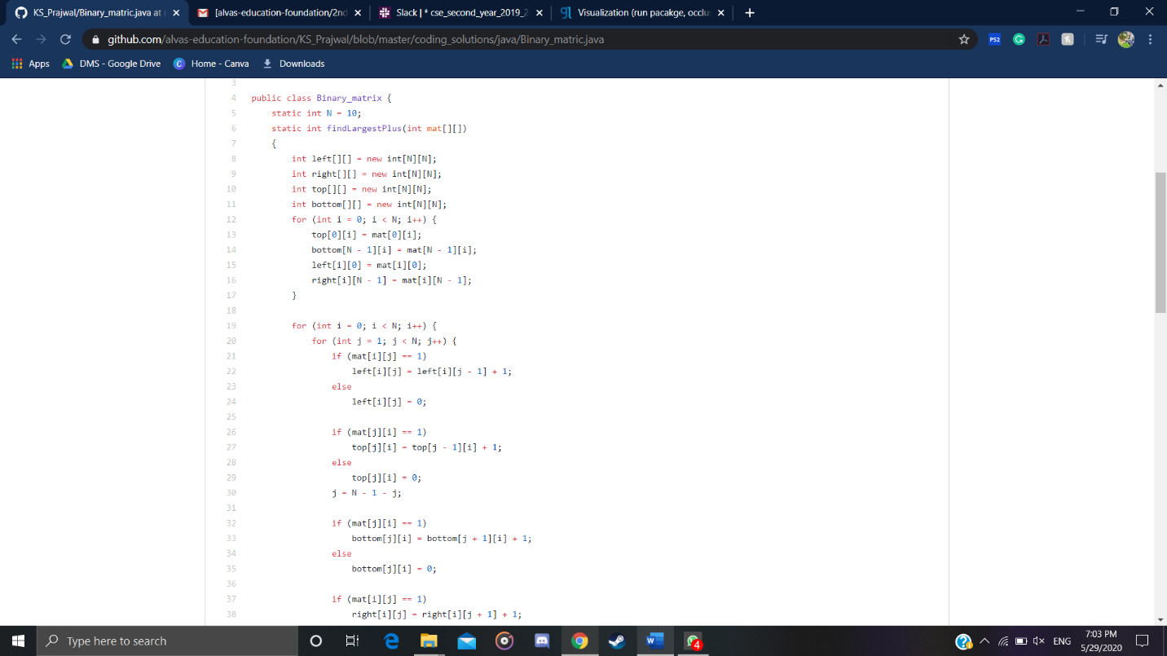

Problem 2: (Using c language) Write a C Program to generate first N Armstrong Numbers

